You are required to deploy a Flask backend and an Express frontend application using AWS and Terraform. Follow the steps below to deploy the applications in different configurations.

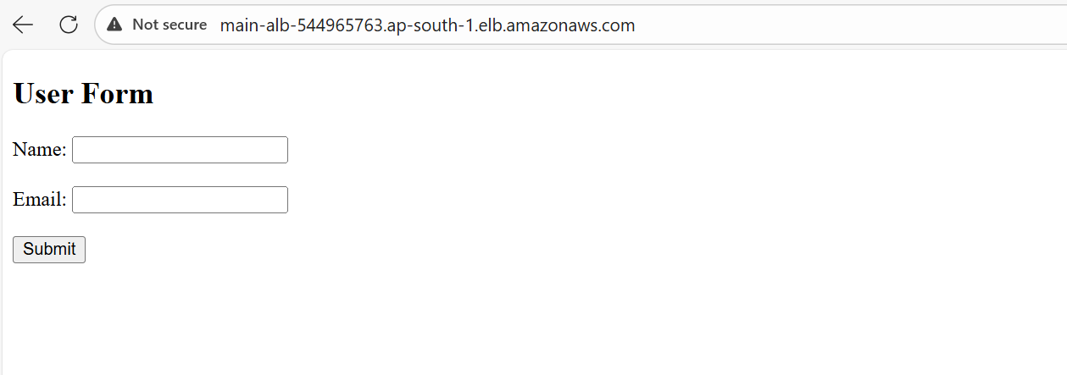

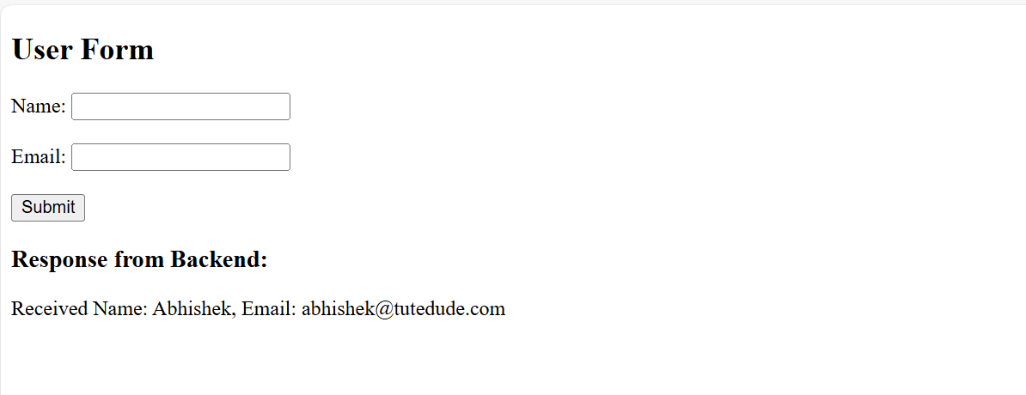

Commands:
- terraform init (initialize)
- terraform fmt (format)
- terraform validate (validate)
- terraform plan (preview changes)
- terraform apply (deploy)
- terraform output (see outputs)
- terraform destroy (remove resources)

